Making Forms Accessible
Like tables, forms require extra effort to make visible information usable by assistive technologies. Forms require even more detail. In this tutorial, we will look at some basic features and examples of common software programs to ensure all form fields have accurate labels or prompts so screen readers accurately help users know what each field is asking for. This tutorial will focus on Microsoft Word and Adobe Acrobat Pro. Additional resources are listed at the bottom for further exploration.

Microsoft Office Tools
The steps to access tools and develop forms are largely the same in Office tools. The Developer tab is not shown by default, but it is easy to add and get started.

Show the Developer tab
Begin by choosing the File tab and select Options from the Info menu.
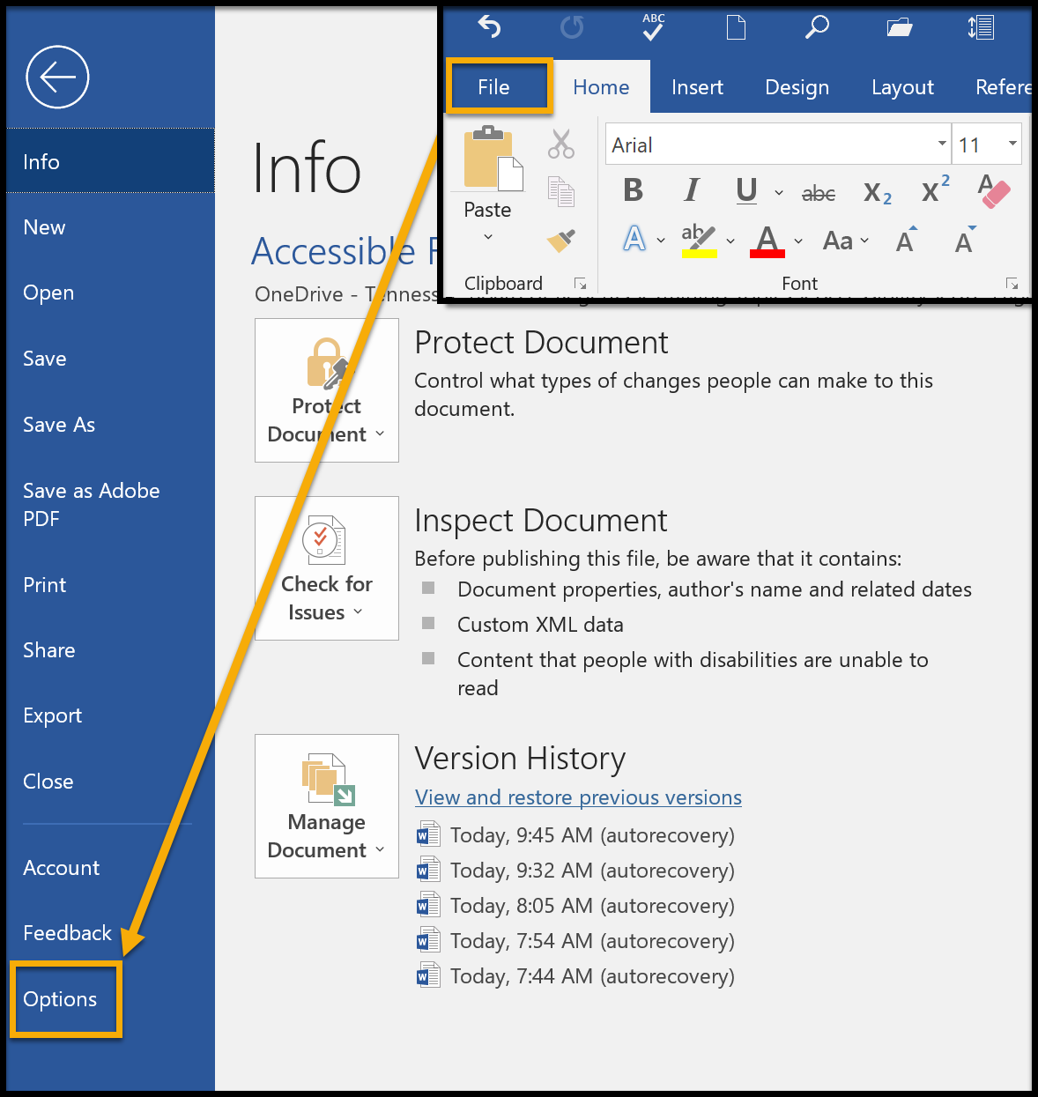
From the Options page choose Customize Ribbon. In the Choose commands from the menu, select Main Tabs. Select Developer from the list. If Developer is already on the Customize the ribbon menu, then it may need to be checked to display.
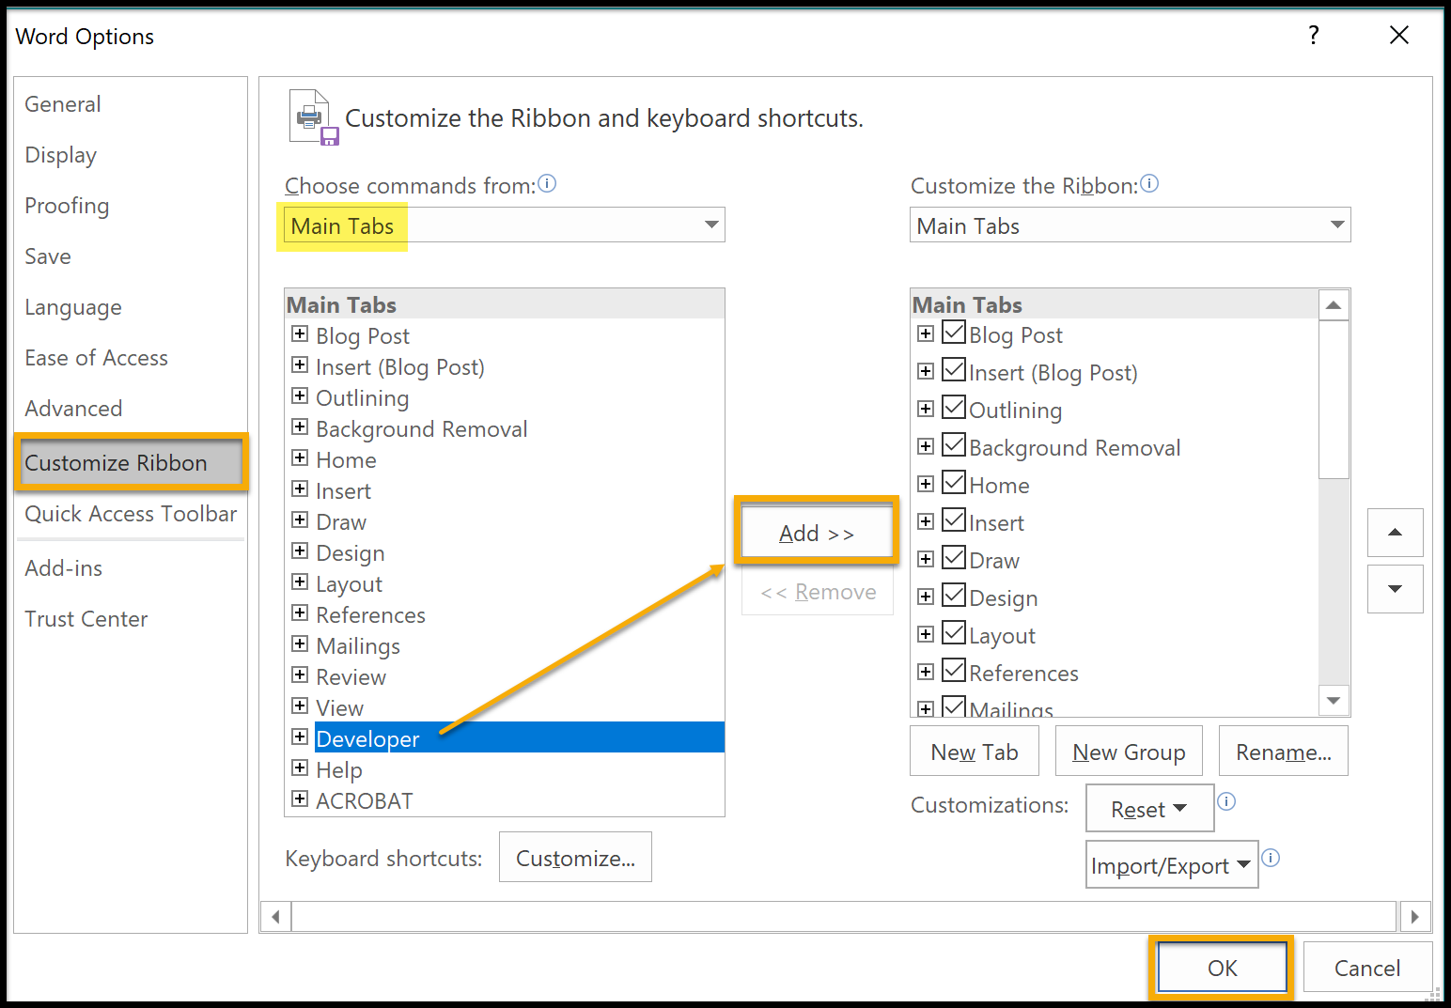

Developer Tools
Opening the developer tab reveals tools that can be used in form fields. They cannot be made accessible. Do Not use them.
Locate the Legacy Forms icon (toolbox) in the same section. This action also reveals ActiveX controls. Only use the Legacy Forms to create accessible forms. The Legacy Forms in Microsoft Word are limited to Text, CheckBox, and Drop-Down form fields. If other features like radio/option button or combo box fields are needed, they are available in Adobe Acrobat. It is recommended to make the form as complete as possible in Word, and convert to PDF to tweak any remaining features.
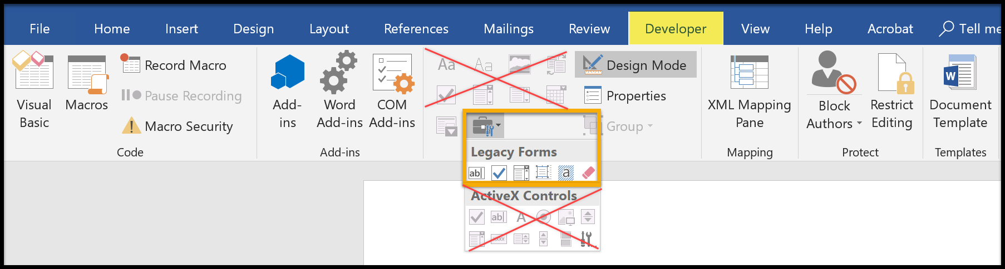

TextBox Form Field
Add a text box field to a document. Place the cursor in the edit field. Right-click and choose Properties.
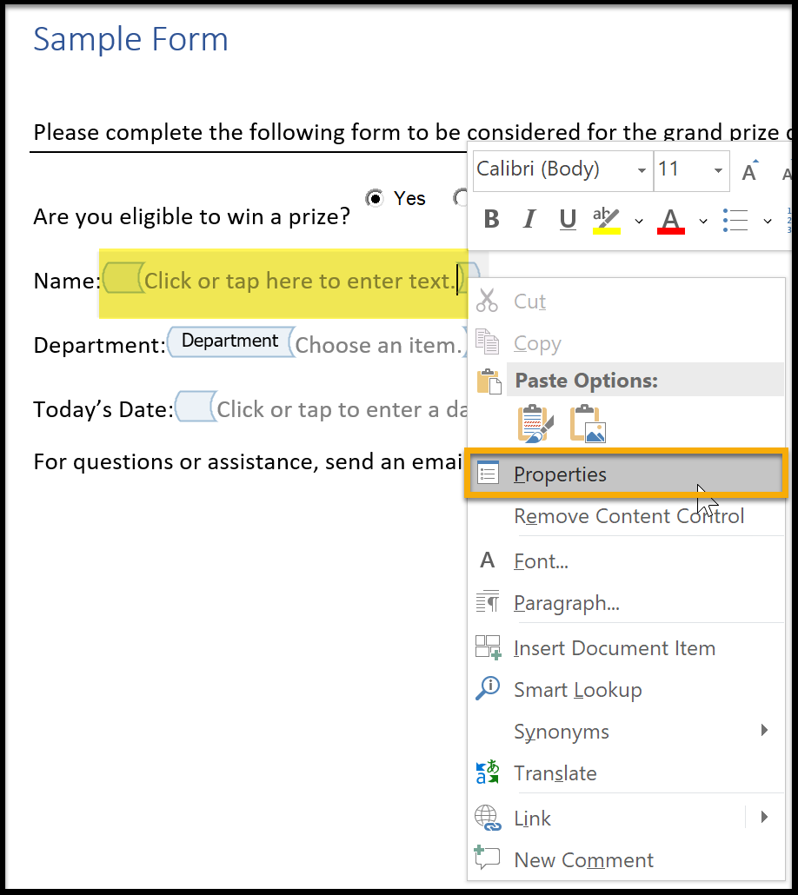
Text Form Fields Options opens. Change the Bookmark text to the text of the item. Choose Add Help Text.
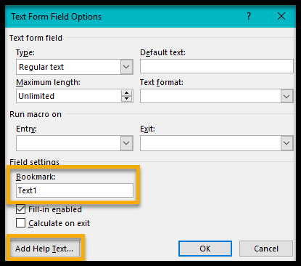
Add descriptive text to assist anyone using a screen reader. This is limited to 138 characters.
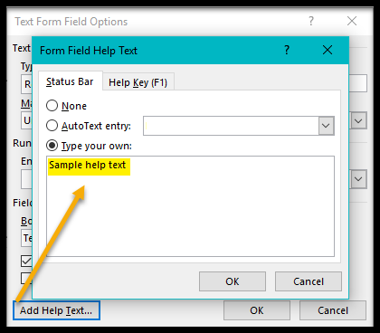

Checkbox and Drop-down Form Fields
Checkbox and Drop-down have the same option to update the text for Bookmarks and Help Text. Continue the practice developed for Text form. Drop-down forms do have the added step to create, arrange and possibly remove menu items. Choose OK to finish.
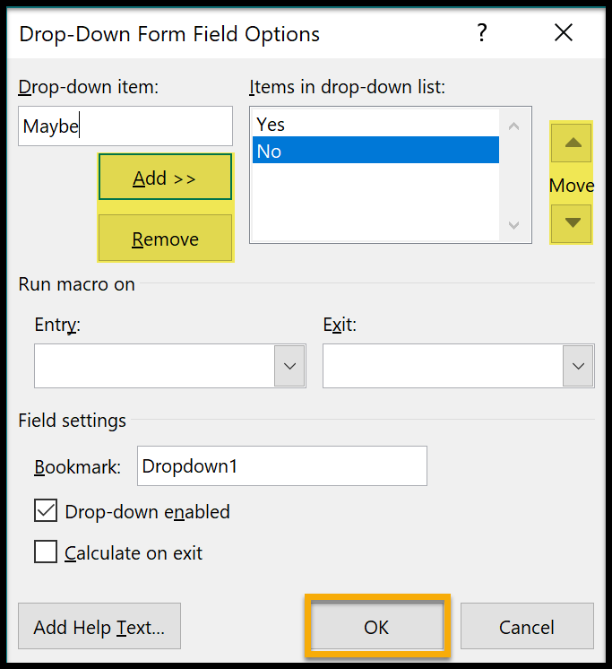

Accessibility Checker
Run the Accessibility Checker in Word when finished. This is a good double check of the work performed and may catch some missed opportunities.

Export to PDF
If the form is needed in another file, such as PDF, then choose the Export option over choosing Save As PDF. The latter does not carry over accessible features. From the File menu, choose Export. Select Create PDF. Choose a file name and select Options. Be sure Convert Word Headings to Bookmarks is checked. Choose OK when finished.
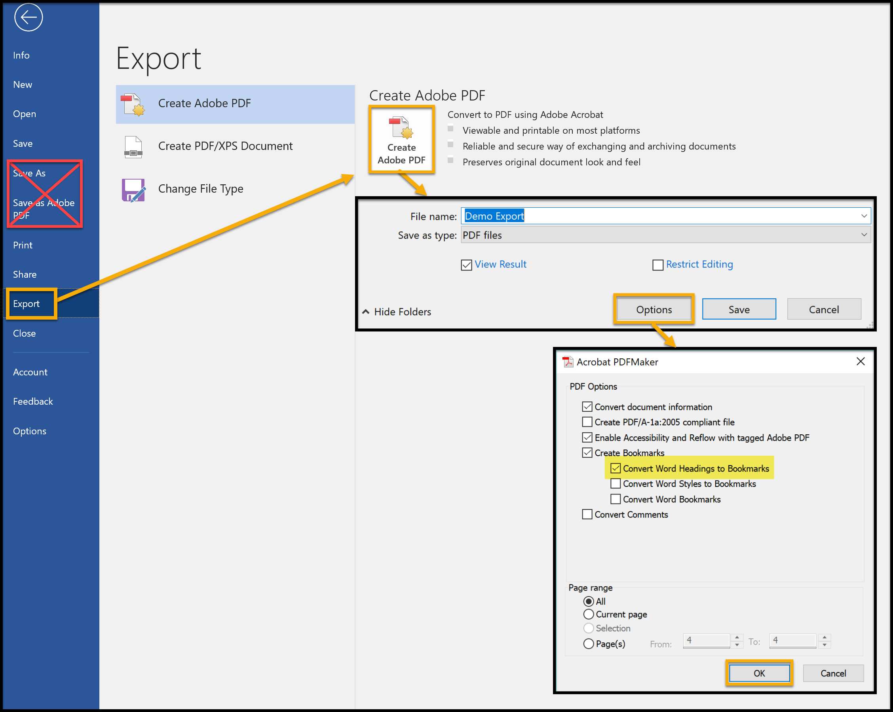

Adobe Acrobat Pro
Reader level software can be used to fill forms, but the pro version is required to edit and make accessible documents. While Acrobat Pro could be used to develop forms from scratch, it is highly recommended to use another source document. Microsoft Word is useful for simple forms. Adobe InDesign has more comprehensive features, but using InDesign is beyond the scope of this tutorial. There are several steps to making previously developed forms accessible.

Steps to More Accessible PDF Forms
Begin by confirming the form is “fillable”. Click the first edit form field and try to add text. If is not fillable, run the Make Accessible feature within the Action Wizard tool. Return to the PDF tutorial (same frame) in this submodule for additional assistance on this topic. This will provide a good starting point with an inaccessible document. Later, it is a good idea to repeat this process to confirm.
Check the tab order. Place the cursor in the first field and press the tab key through all form fields. If they are not in the right order, open the Prepare Form tool.
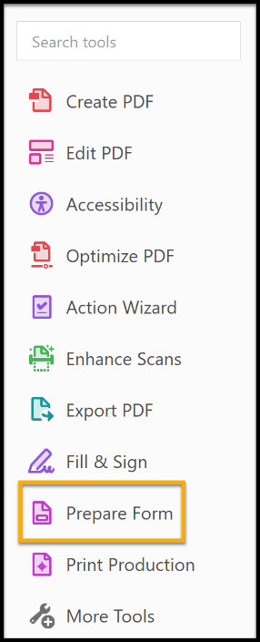

With the actual form in the center panel, notice the right-hand panel has the form fields in list order.
Expand radio button groups or similar items. Everything should be listed in the proper order from top to
bottom. If not, move any needed items Up or Down the list by dragging to the correct position.
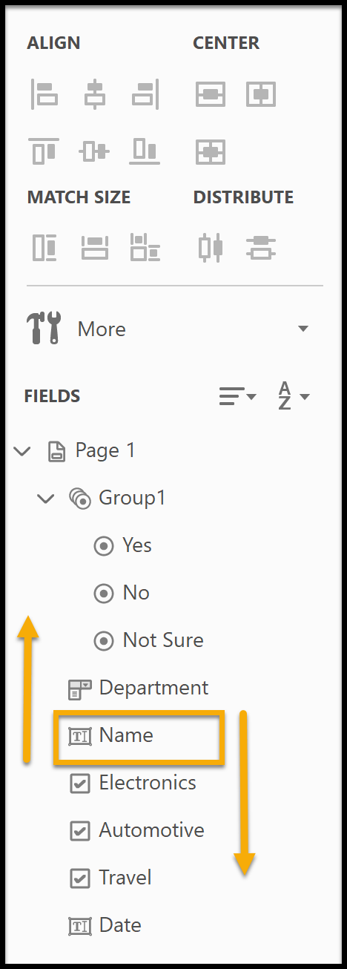

Check all the text fields for appropriate labels called Tooltips. Go to the form. Right-click the first form field and select Properties. Properties will open with the General tab. The Name should be the text of the form item. The tooltip can be the same but be sure it is descriptive enough to guide someone using a screen reader. This is especially important if some fields repeat in different sections. For example, a form might ask for multiple names and email addresses. Repeat with all other form fields.
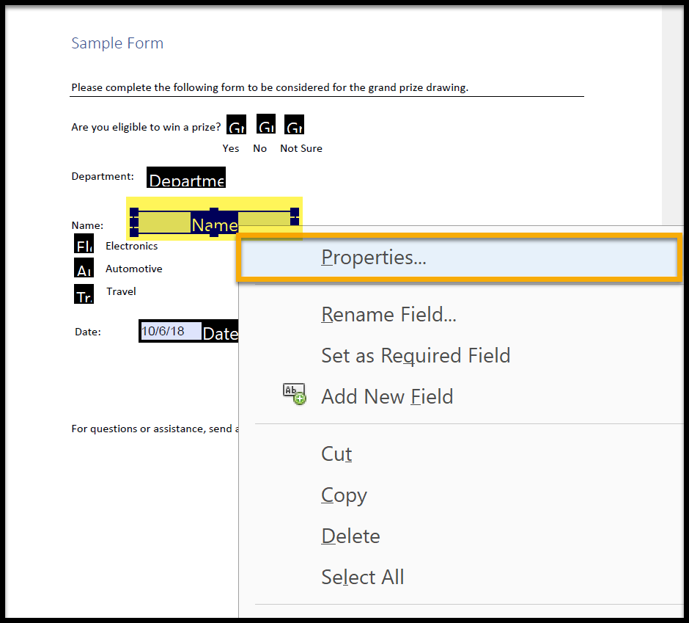

This example has a very simple form. Name is a sufficient tooltip. There is also a checkbox to make the field required. Leave this unchecked if not needed.
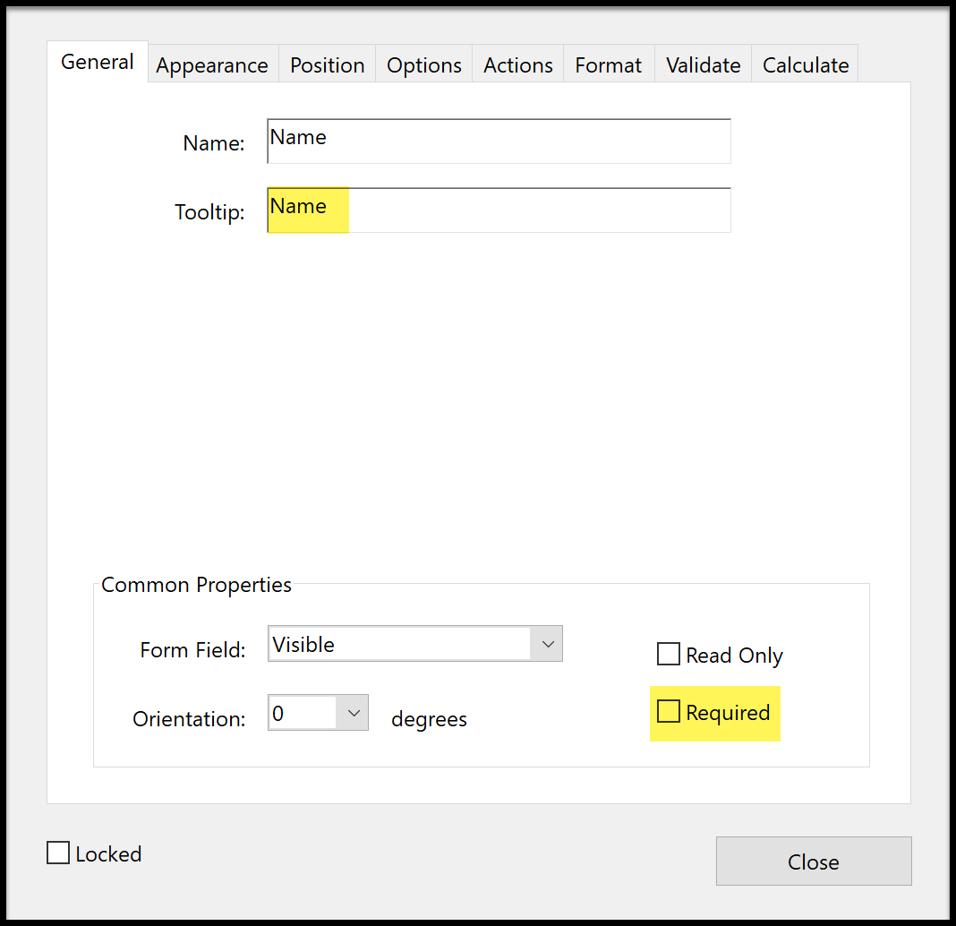

Radio / Option buttons should have the same group and tooltip name. This can be checked by going to Properties as shown in the previous example. Choosing the Options tab reveals choices about the radio button, including the Button Style and Radio Button Choice. The choice is what is read by a screen reader. “Yes” is one of 3 choices for the button group. Radio buttons can have only 1 choice selected at a time.
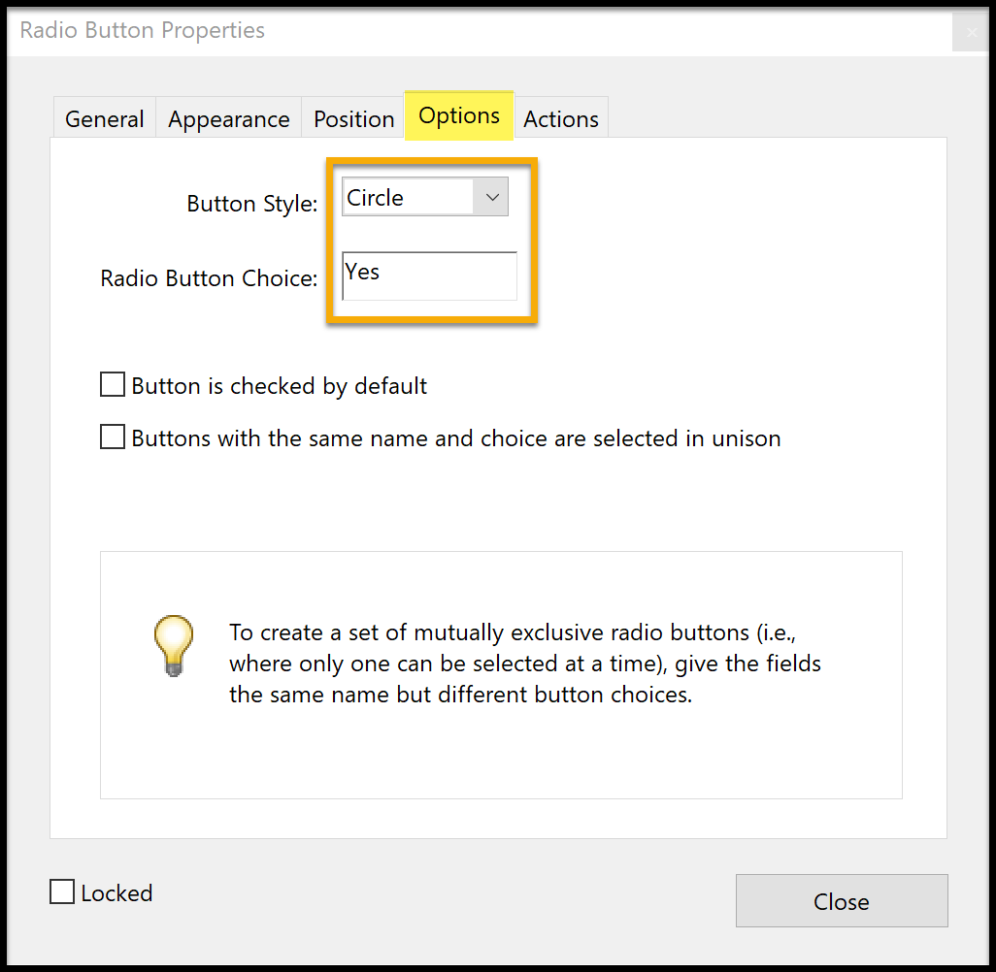

Check Boxes appear to be very similar, but checkboxes can have multiple answers, unlike radio/option buttons. The field name and tooltip cannot have the same entry. The checkbox name must be the item question or topic to check. The tooltip must be the question or topic plus the field name. In the example below, Electronics is one of the selection options under the topic, Choice. Choice: Electronics becomes the tooltip name. Choose Close when finished. Make all of the checkboxes with the same strategy. Automotive is the next check box in this survey. The name would be Automotive and the tooltip would be Choice: Automotive.
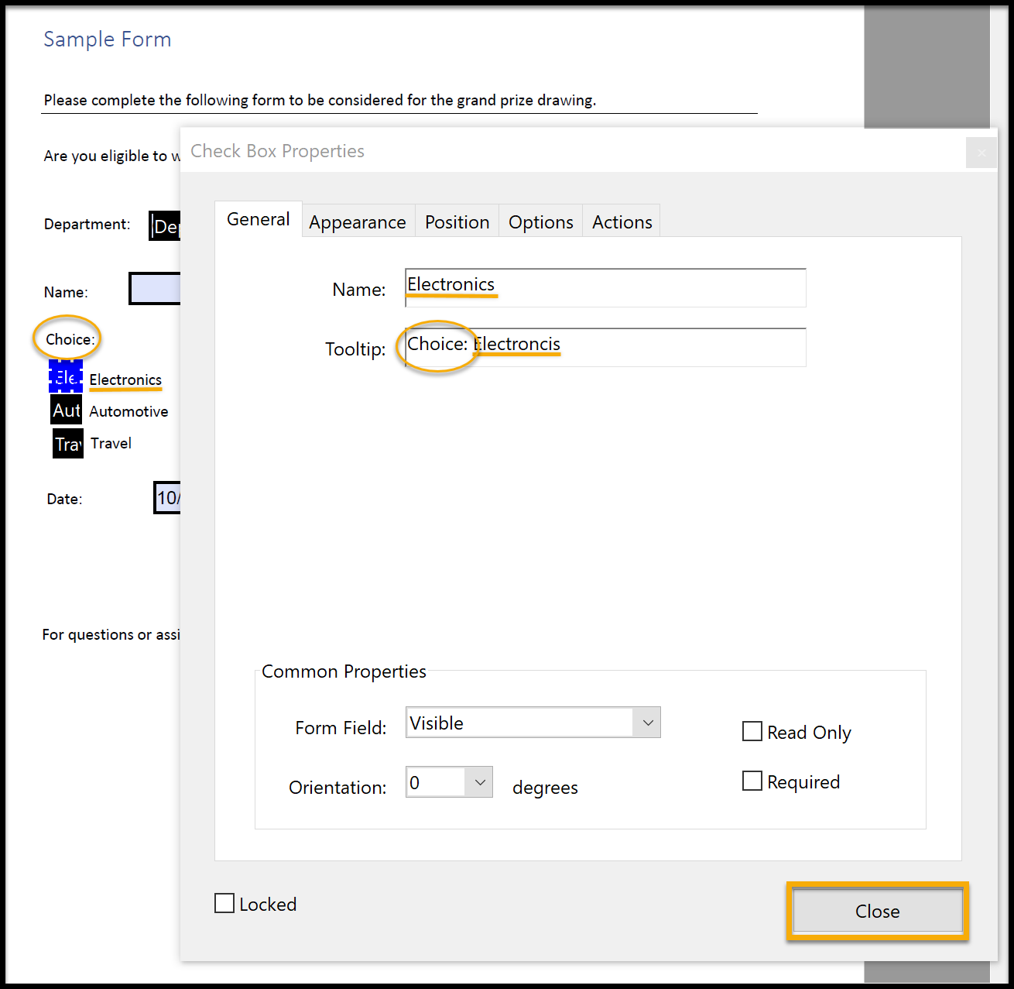
Dropdown menus have one name field and the same tooltip name but offer a predefined list of responses to choose from the menu. This is an excellent way to have a multiple-choice response with data entry precision. In this example, Department answers could be entered Math or Mathematics in a text box, but Dropdown lists give the form developer a way to control responses. (There is also an option to allow users to fill in their own choice.)
Under the Options tab, the list can be developed by entering and choosing Add. The order can be adjusted by selecting the response and choosing Up or Down.
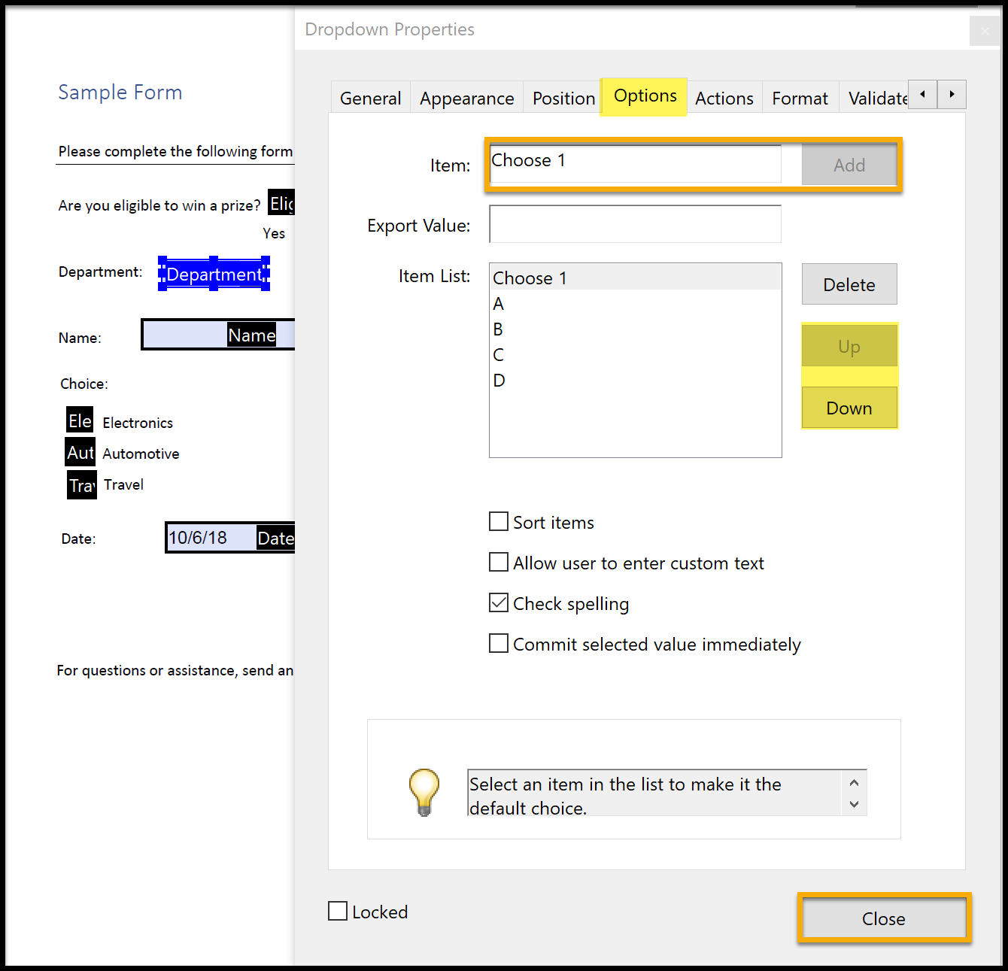

Tagging the Form
If this document has no tagging or was poorly tagged, then use the Auto Tag feature in the Accessibility tool. This will give a baseline to start from.

Checking the Form
There are other form choices, but these are some of the central ones used. Once the form has been edited and each section checked, it is a good idea to run the Accessibility Full Check. This may catch some missed opportunities and will confirm a reasonable effort has been made to ensure the document is accessible. The image here highlights Auto Tagging and Full Check.
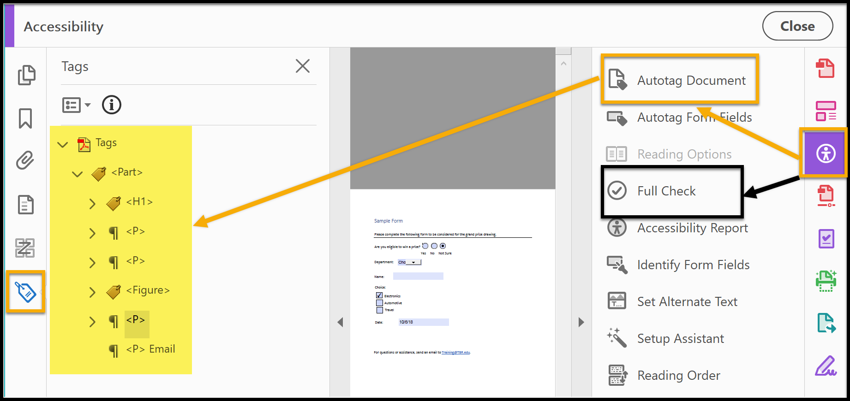

Additional Resources Forms
Making Tables Accessible (new window)
Word 2013 & 2016: Creating Accessible Word Forms (new window)
Excel 2013 & 2016: Accessible Excel Forms, Part 1 (new window)
Excel 2013 & 2016: Accessible Excel Forms, Part 2 (new window)

