Making Acrobat PDF Files Accessible

Introduction
Being accessible is like peeling layers of an onion. Part of making resources accessible depends on the complexity of the document. There are also finer and finer details to evaluate for full accessibility. Here will cover some important steps to make simple PDF documents reasonably accessible with limited effort and expertise. With that said, It is highly advised content from PDF documents be redeveloped in HTML pages. There will be far fewer accessibility issues and future changes will be much simpler.
In this tutorial, we will look at some of the root areas of accessibility and PDF documents:
- Source Documents
- Getting to Know Pro
- Document Title
- Document Tag
- Headings
- Lists
- Reading Order
- Additional Resources

Source Document
The source document is king! Acrobat has strong accessibility features, but it is not the ideal place to create accessible documents or make major edits to content. Exporting an accessible source document into a PDF file is the best practice. This submodule has specific content regarding the steps to successfully make accessible and export files for MS Word, Excel and PowerPoint. Please refer to those tutorials for help.

Getting to Know Acrobat Pro
You have probably used Acrobat Pro’s non-editing cousin, Acrobat Reader, or other “reader” programs. Reader programs or browser windows are typically set as the default method to open PDF files. Unless users have Adobe Pro set to be the default program to open PDF files a reader program or browser window will open. Many users prefer to view files in a browser window instead of opening the pro version of the program for speed and simplicity, but to make documents accessible, only the pro versions will work. It is best to get in the habit of opening files through the Acrobat Pro by choosing the Home tab at the top. Then, choose the storage location to open and edit files.

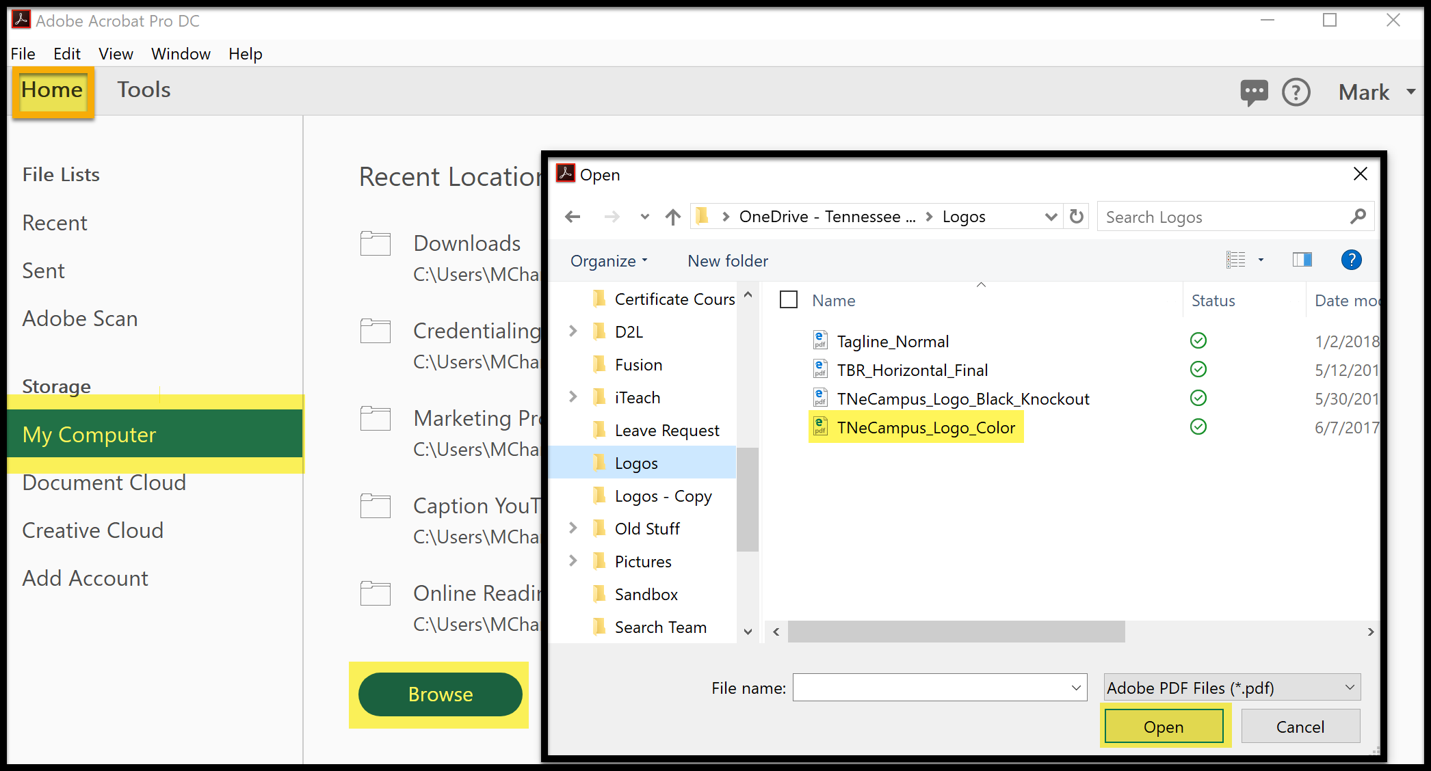
Organizing Tools Set
By default, Adobe limits the tools shown on under the Tools tab. Choose More Tools to add new tools to the quick access list. Choose Add Shortcut for Accessibility and Action Wizard. These tools are used frequently for basic accessibility procedures. PDF Standards, Optimize PDF and, Print Production are also useful for advanced procedures. Tools may be removed to keep the list focused. Tools in the main list marked Open appear on the right pane of the Tools tutorial. 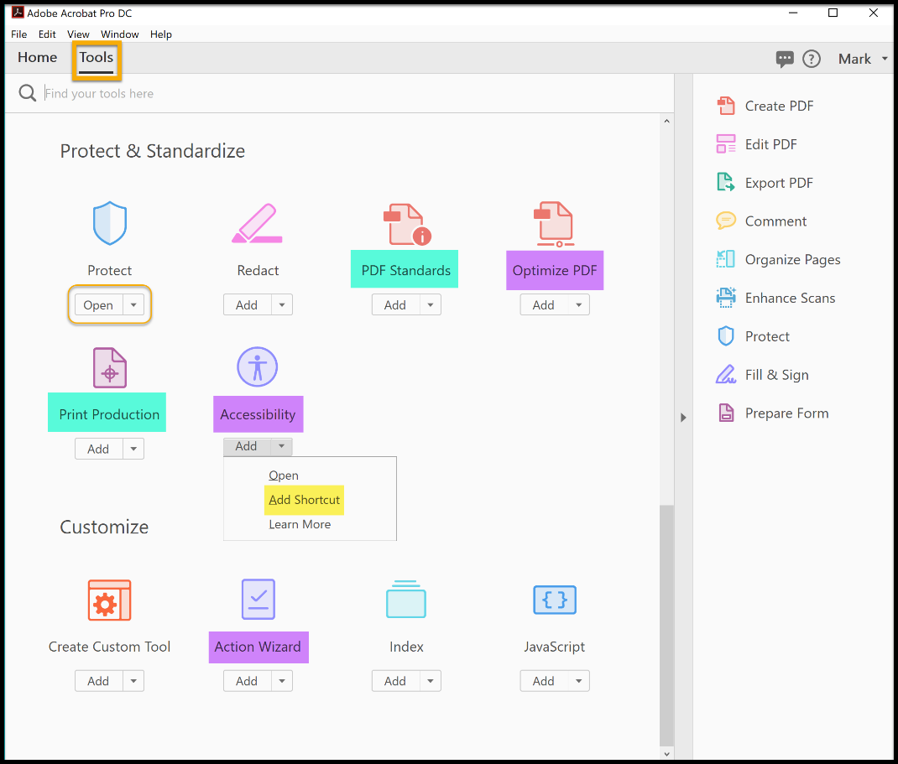

Navigation Pane
From the menu bar, open View to Show/Hide to Navigation Panes and add the following items for the Navigation pane: Content, Order, and Tags panel. These panels will be used frequently. (A file must be open to select panels.) The panels will remain in the pane for future use.

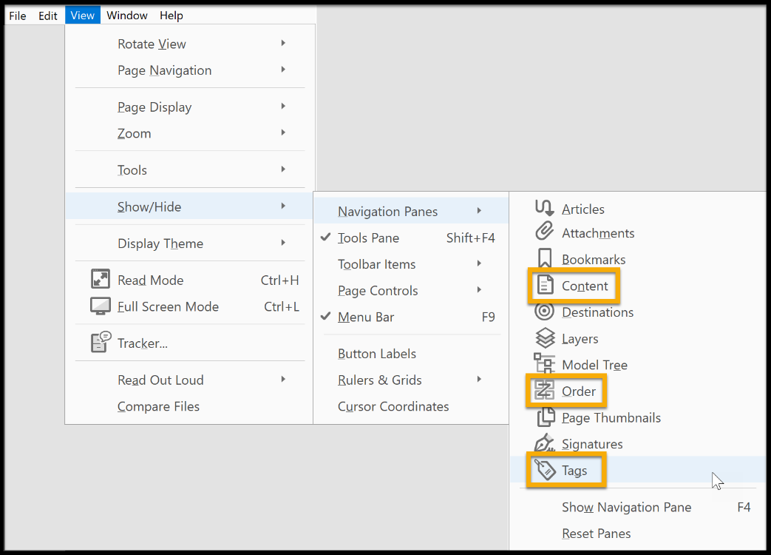
Check for panels added in the left-hand pane.
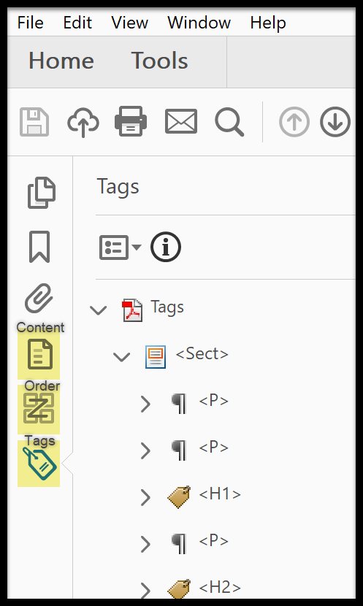

Adobe Action Wizard
The Action Wizard is a multipurpose tool. By choosing Make Accessible, users can check many features in a step by step process or just choose the ones needed. Choose Start to run through the entire list. In this example, choosing Add Document Description opens the fields to a documents title, subject, author and keywords can be set by unchecking each field and adding the new information.
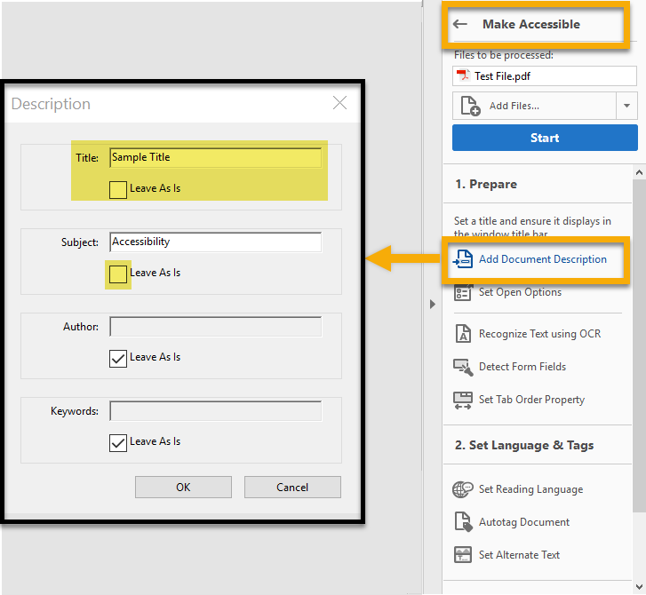
Document properties can also be modified by choosing File and selecting Properties. Both methods will update the content.
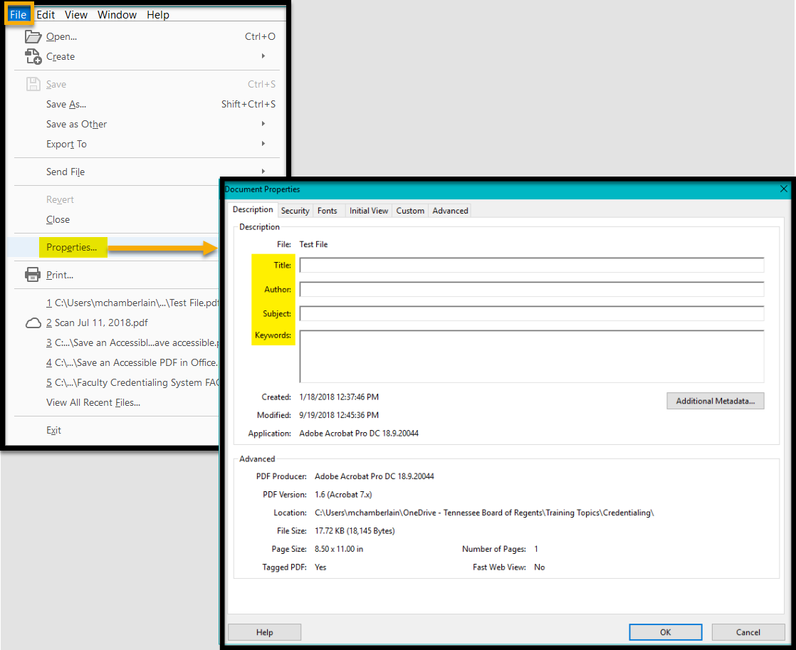

Alt Text, Document Language and OCR
The Action Wizard will also prompt users to check or adjust several other areas. Follow the prompts and adjust as needed. A more in-depth section will cover documents with images, tables, and forms in other tutorials.

Update Document Tags
At a very minimum, a simple document’s headings, text and lists need to be correctly tagged. These are among the easiest to check and correct by hand. Choosing the Tag Panel icon will present the document’s tags in a hierarchical list. Tags can be selected and adjusted through their tag properties. Additionally, the Reading Order tool has another function by selecting the Structure types radio button. Instead of reading order, users can edit tags. Both are pictured below on the same screen. (Link to KB for tagging examples and detailed steps?)
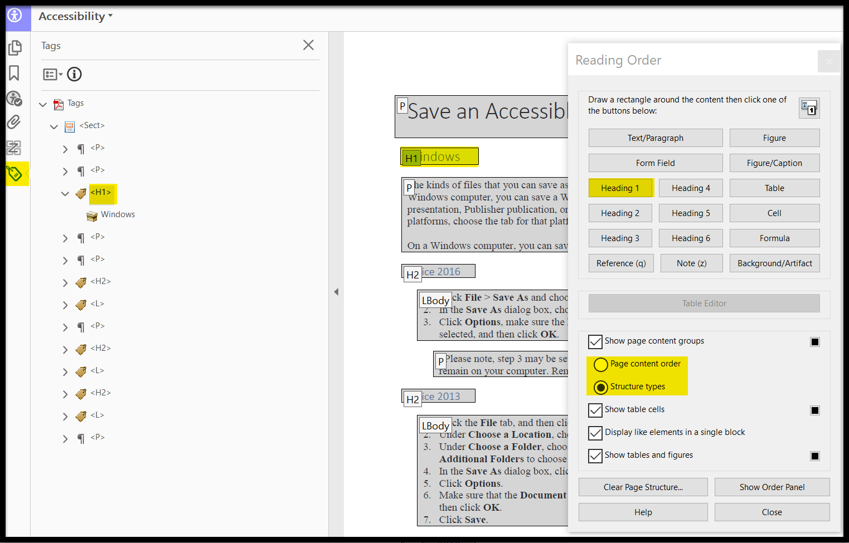
The Options icon has a menu of frequent resources. Moving from top to bottom. the list starts with New Tag. It is tempting to try to edit an existing tag by choosing New Tag, but that should only be used when a tag is missing, such as a Document tag. Deleting a tag can have unexpected consequences by removing related items. Deleting Empty tags can be used once tagging is complete. Selecting text and choosing to Create Tag from selection to tag untagged content. Choosing Properties is the easiest way to edit a tag type and much more. Use Properties to make corrections to existing tags.
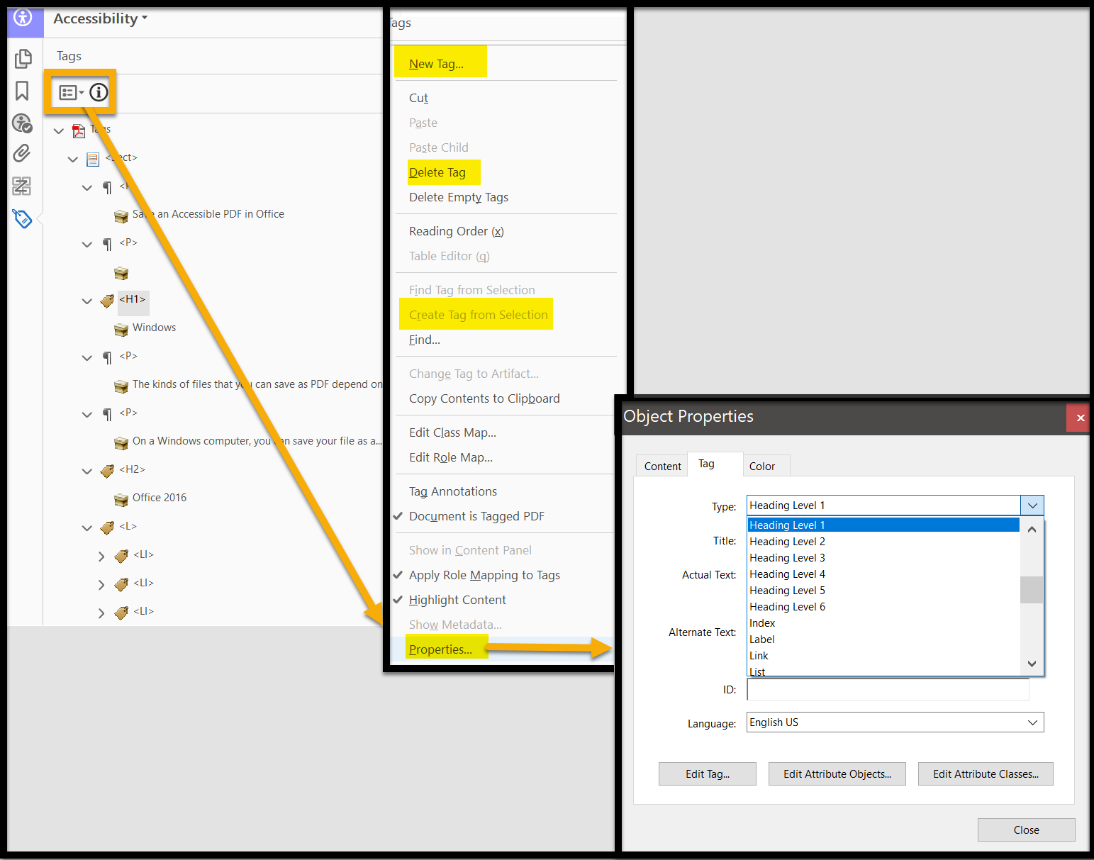

Auto Tagging
Acrobat Pro has an Auto Tag feature in the Accessibility tool (also available in the Action Wizard). This feature can be useful for a document with no tagging to create a tag starting point, but this action will need further review to be sure it is correct. This is a useful feature, but if a source document has substantial accessibility or content issues, then consider improving the source document before making big edits and improvements in Acrobat Pro. If an exported document is missing accessible features found in the source document, then it may not have been exported correctly. Recheck the exporting steps to retain the accessible features. (Link to steps tutorials).

Tag Resources
Some complex documents will use tags beyond the typical user’s experience or knowledge. Accessibility in mind (new window) offers a simple resource to explain a variety of tag types and how they are used. The Acrobat User Guide (new window) also offers detailed information regarding tag types. This link opens to that section, but the entire page is devoted to tag issues such as: using the Content panel, containers, parent, and child level tags. It is a good resource for anyone learning about accessibility features.

Lists and Ordered Lists
Lists should always be created in the source document. Ordered lists should only be used if the order really matters to the end user. Always check for list tags. You can also try to copy list item text. If you can select the bullet or number, it is not a list.
Also, consider if lists can do the work of tables. Tables can convey information powerfully, but they also may pose challenges to accessibility. Consider how using screen readers and other aides will function. A list could simply the delivery of the information.
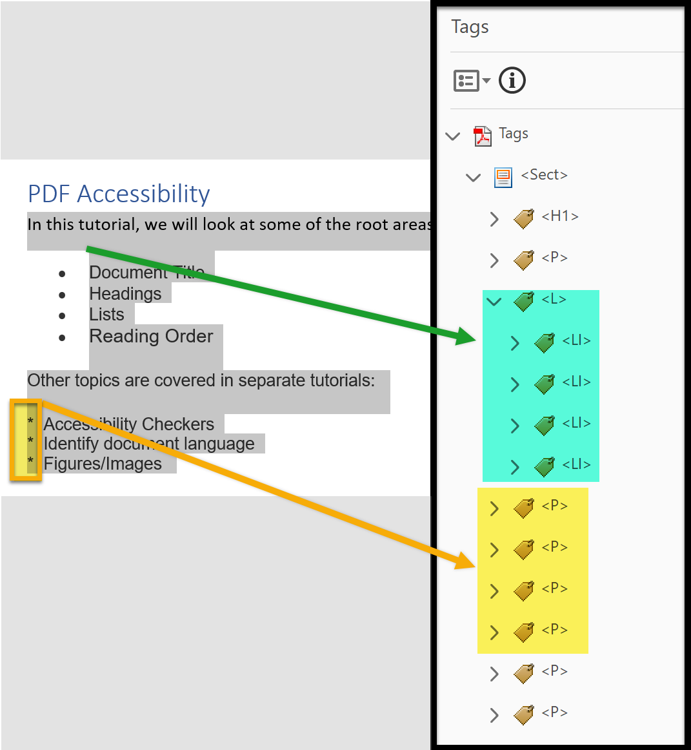

Update Reading Order
It takes a human eye to determine the best reading order in complex documents. The Touch Up Reading Order Tool (TURO) is useful to see and adjust the order. If Auto Tag was used, simple headings and paragraphs are generally well suited to identification, but should be checked. If this TURO is not open, Choose Accessibility and Reading Order. Change the radio button highlighted below to Page content order to edit the reading order. It may be necessary to choose Show Order Panel if other panels were previously open.
In the image, notice the Order panel is open on the left-hand side. The document contents are listed in a hierarchical order. Edits can be made by dragging and dropping within the panel. The same changes can be made from TURO on the right-side as well. The tool choice is up to the user.
Sometimes a background item or scanned artifact is assigned a number (and a tag). Those items can be updated or removed. Tables and forms are addressed in other tutorials (link).

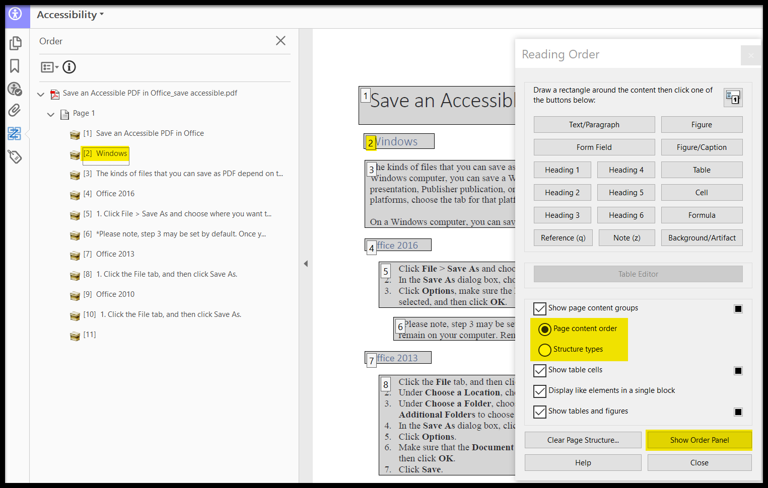

Full Accessibility Check
After making accessibility changes, it is a good idea to check the work. Use the Full Accessibility Check, which may have been run as a part of the Make Accessible wizard at the beginning of this tutorial. It can also be deployed by opening the Accessibility tool.
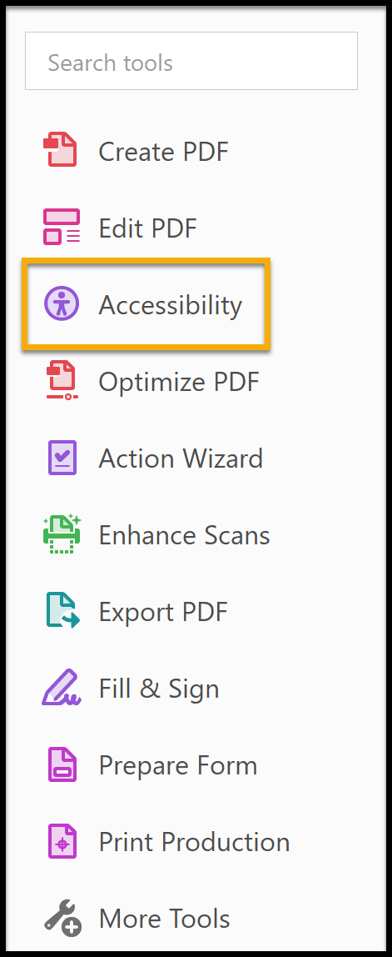

Use the default full check settings (leave all checked) and choose Start Checking. The steps to make improvements been covered previously. Apply those same principles for any revealed problems.
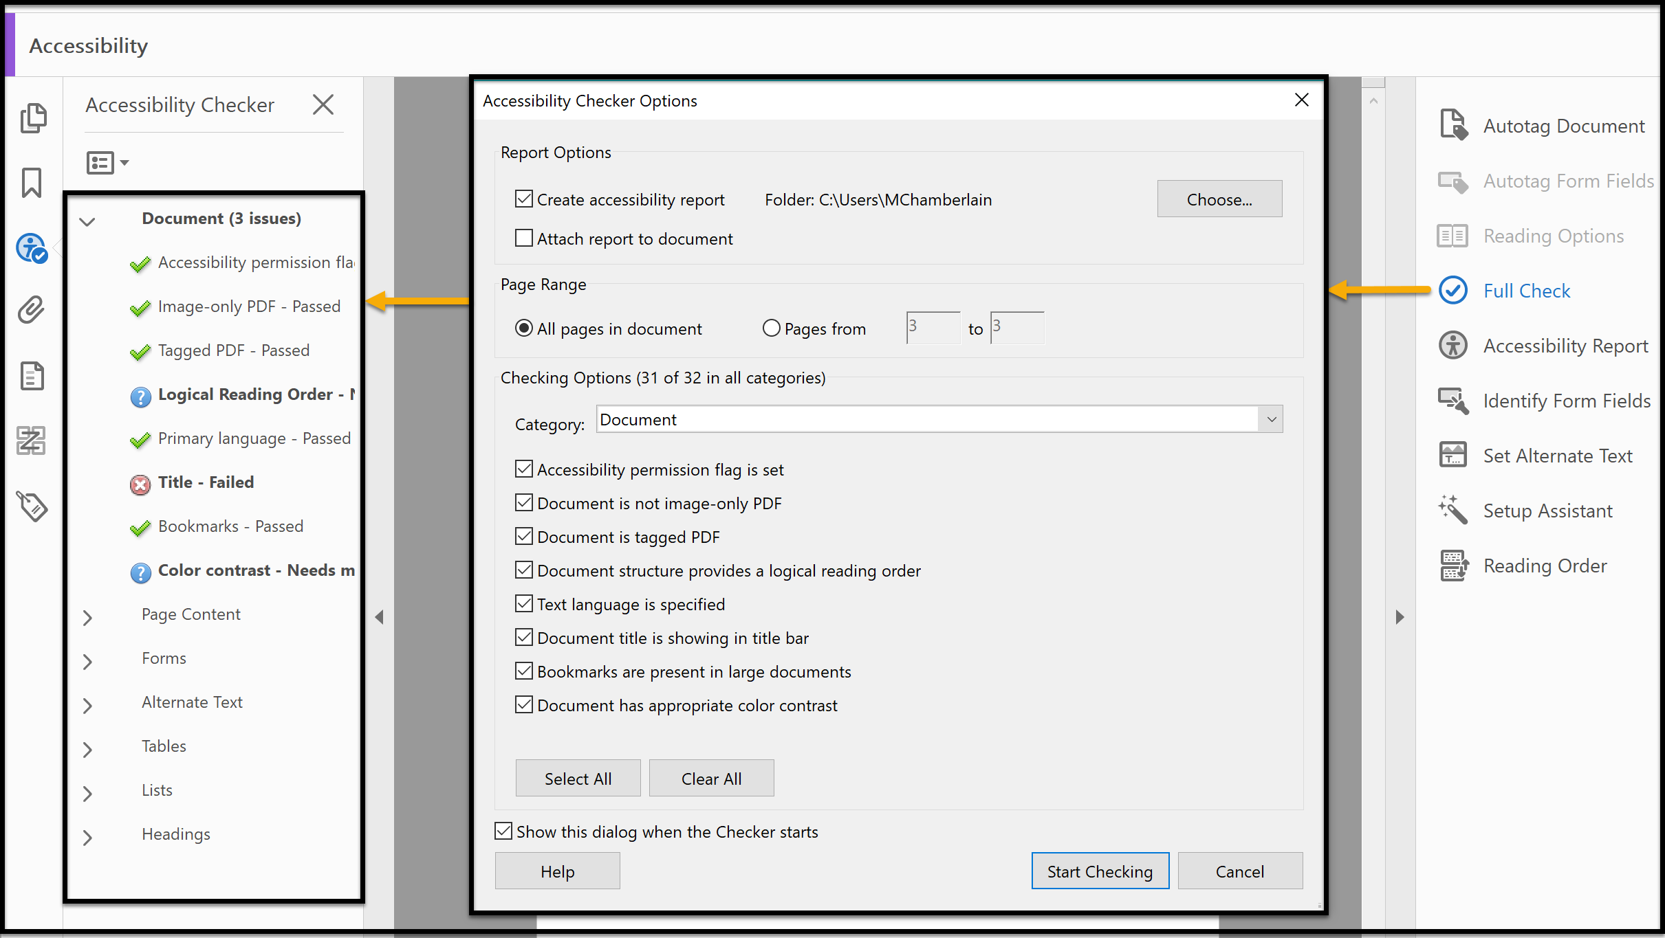
Purdue University has an excellent resource for using the Full Accessibility Check (new window).

Additional Resources

Word 2013 & 2016: Converting to PDF (new window)
Adobe Creating accessible PDFs (new window)
Standard PDF Tags (new window)
Tagged PDF Video Tutorials (new window)
PAC 3 PDF Checker for Advanced Users (new window)

